EECS 322 | Sample Test 2 | Wednesday March 21, 2001

Name:

Problem 1 (50%): A group of EECS students have decided to compete with Intel Corporation in the microcontroller market. Their first prototype called the RISCEE1 computer is a 16 bit single-cycle computer build in a secret lab in Olin building.
The all 16 registers, pc, and alu are eight bits wide. Register zero (r0) contains only a zero and cannot be overwritten. There is only one instruction format shown as follows:
Opcode  4 bits  15-12 | Register  4 bits  11-8 | Data or Address field  8 bits  7 - 0
The delay time of the functional units are as follows Memory Write 5 ns, Memory Read 3 ns, Register (read or write) 2 ns, and ALU & Adders 2 ns.

(a) Fill in the settings of the control lines determined by the all the instructions (use X for Don’t Care)
Instruction | Operation | RegDst | A | MemWrite | RegWrite | BZ | P0
addi reg, data8 | reg = reg + data8
subi reg, data8 | reg = reg – data8
load reg, address8 | reg=Memory[address8]
store reg, address8 | Memory[address8]=reg
beq reg,address8 | If (reg==0) { pc=pc+address8; }
jmp address8 | pc = address8
jal reg, address8 | reg=pc+2;pc=address8

(b) Write“fail” for instructions will stuck-at-fault for RegDst
Instruction | RegDst Stuck-at-0 | RegDst Stuck-at-1
addi
subi
load
store
beq
jmp
jal

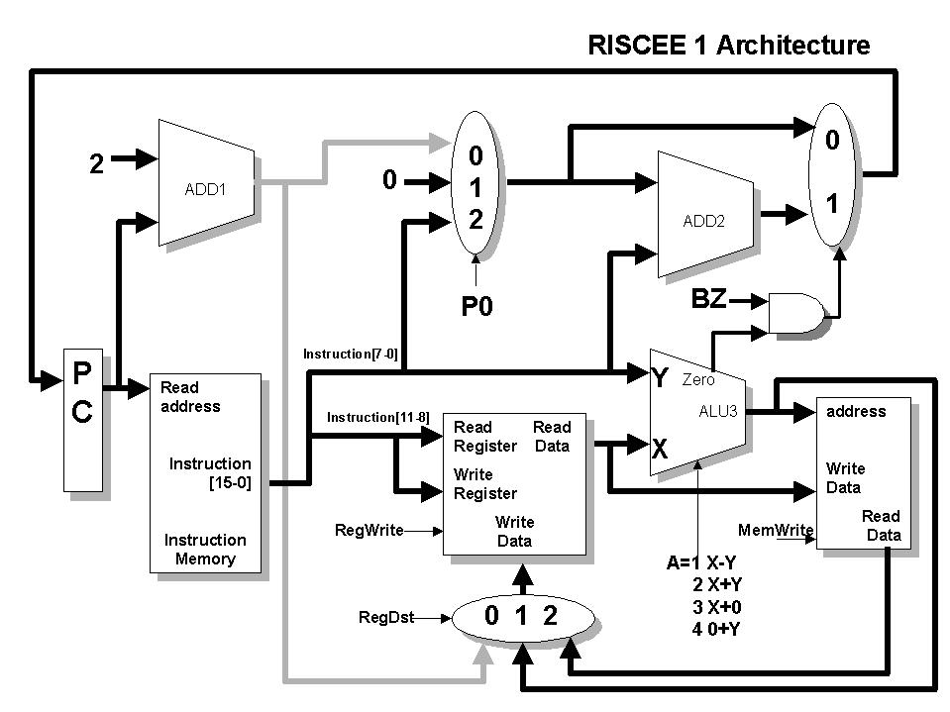
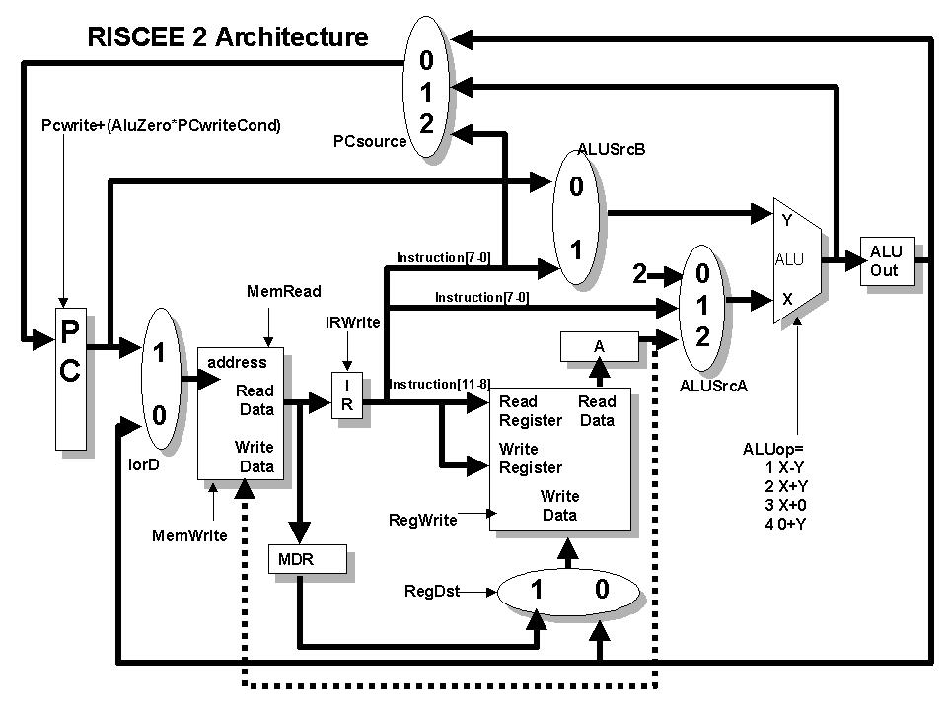
(c) Fill in critical path times for each instruction.

Instruction | Instruction memory | Register Read | ALU operation | Data Memory | Register Write | Total  Time | Clock  Cycles | Instruction Mix
addi |  |  |  |  |  |  |  | 40%
subi |  |  |  |  |  |  |  | 0%
load |  |  |  |  |  |  |  | 25%
store |  |  |  |  |  |  |  | 10%
beq |  |  |  |  |  |  |  | 25%
jmp |  |  |  |  |  |  |  | 0%
jal |  |  |  |  |  |  |  | 0%
Clock
Speed
 |  |  |  |  |  | CPI
 |  |  |  |  |  | MIPS

(d ) Fill in the Clock, CPI, and MIPS in the above table and show all calculations (Hint, single-cycle computer).

(e) Using the RISCEE1 instruction set, show how to swap two registers r1 and r2 (hint, use memory).

Problem 2 (50%): The brokerage firm said they talked to their investors and said they will only invest in multi-cycle computers. Furthermore, CPU Benchmarks showed that the subi, jmp, and jal instructions are not used.
- Draw the finite state machine for multi-cycle RISCEE 2 architecture (addi, load, store, beq), show all states.
- Place next to each state the amount of time needed to process that state.
(c) Fill in critical path times for each instruction (copy delay times from part b).
Instruction | Instruction memory | Register Read | ALU operation | Data Memory | Register Write | Total  Time | Clock  Cycles
addi
load
store
beq

(d) Determine the fastest clock speed for the computer to work properly in frequency and show why.

(e) Fill in the Clock, CPI, and MIPS in the above table and show all calculations.
Instruction | Clock  Cycles | Instruction Mix
addi |  | 40%
load |  | 25%
store |  | 10%
beq |  | 25%
Clock
speed
CPI
MIPS

(f) Suppose you do not know the instruction mix. Explain which one functional unit (Memory write 5ns, Memory Read 3ns, Register 2ns, or ALU 2ns) would you choose to improve by 1 ns and what will be the new clock speed? (show calculations)

Extra Credit which can be only used for this exam and the previous exam.
a) (9%). Assemble the following machine instructions into binary,
Assume each instruction is located at address 0x45891280
Field 1 | Fields 2 and etc | instruction
 |  | j 0x458912A0
 |  | beq $s1,$t4,0x45891380
 |  | jal 0x45891388

b) (2%) Give the two’s complement of the 8 bit binary 0x12

c) (2%) Convert −25 into a 8 bit binary.

d) (2%)Convert the 5 bit signed binary 10010 into decimal

e) (5%) Add 0x2 and 0xF and what is the overflow bit = ________________

Cin

Sum

Cout

f) (5%) Multiply the 3 bit signed numbers 010 by 110 into a 6 bit signed number.

