EECS 314: TEST 2 4 March 2002

Solutions

Q1 (a)

0 0 1 X
0 1 0 Y
0 1 1 Z
------
0 0 0 S1
0 1 1 C1
/ / /
0 1 1 C1<<1
----------------
0 0 0 S1
0 1 1 C1<<1
1 0 0 U
------------------
0 0 1 0 S2
0 1 0 0 C2
/ / / /
0 1 0 0 C2<<1
------------------
0 0 1 0 S2
0 1 0 0 C2<<1
0 0 1 0 1 V
-----------------
0 1 1 1 1 S3
0 0 0 0 0 C3
/ / / / /
0 0 0 0 0 C3<<1
---------------------------
0 1 1 1 1 S4
0 0 0 0 0 C3<<1
0 0 0 1 1 0 W
-----------------------
0 0 1 0 0 1 S4
0 0 0 1 1 0 C4
/ / / / / /
0 0 0 1 1 0 C4<<1
----------------------
0 0 1 0 0 1 S5
0 0 0 1 1 0 C4<<1
-----------------------
0 0 1 0 1 0 1 Result

(b)&(c)

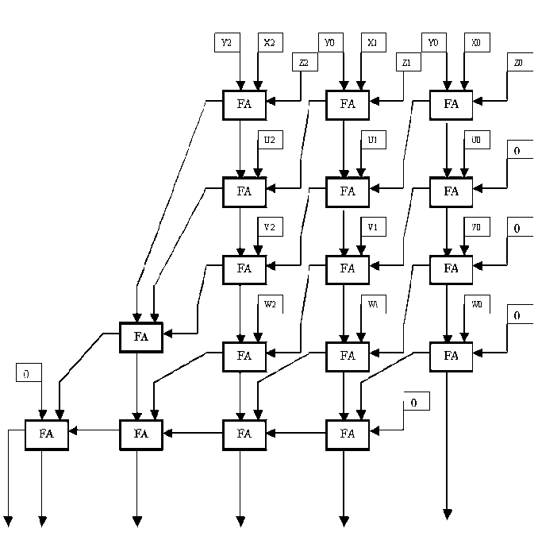

(d)

Longest Path is 8 FA
Delay = 8 * 20 = 160 ns

(e)
X2 Y2 Z2 U2 V2 W2 X1 Y1 Z1 U1 V1 W1 X0 Y0 Z0 U0 V0 W0

FA
c s
FA
c s
FA
c s
FA
c s
FA
c s
FA
c s
FA
c s
FA
c s
FA
c s
FA
c s
FA
c s
FA
c s
FA
c s
0
FA
c s
FA
c s
0

S0
S1
S2
S3
S4
S5

2(a)
A = 1010, a = 0101
B = 1100, b = 0011
X×Y = A×B×2^{a+b}

a + b = 0101 + 0011 = 1000
A × B = 1010
1100
--------------------
0000
0000
1010
1010
-----------------------
1111000
Answer = 1111000 × 2 ¹⁰⁰⁰

2(b)
Shift right enable
Shift register
A
0000
Adder
Register
(Shift register)
Product
(Shift register)
Clk
c
o
u
n
t
e
r

1 0
Adder enable
a + b
Adder
b
a
Exponent
Mantissa
B
Overflow
Carry Out

2(c)
Overflow should be checked with the exponent field i.e. 2 ^{(a+b)} , you need to check the carry bit of the exponent addition (a + b). To avoid exception you could use 2 four bit registers for the exponent addition.

2(d)
It will take 80ns to multiply the given data because you need to do 4 times shift right and 4 times add so
4(10 + 10) = 80ns.

Q3.

(a)

(+22) 010110
+
(-11) 101011
₋₋₋₋₋₋₋₋₋₋₋₋₋₋₋₋₋₋₋₋₋₋₋₋₋₋₋₋₋₋
01011 è result is ( 001011 )₂ = ( +11 )₁₀

(b)

(+22) 010110
+
(-11) 110100
₋₋₋₋₋₋₋₋₋₋₋₋₋₋₋₋₋₋₋₋₋₋₋₋₋₋₋₋₋₋
001010 è result is ( 001010+1)₂ = ( 001011 )₂ = ( +11 )₁₀

(c)

(+22) 010110
+
(-11) 110101
₋₋₋₋₋₋₋₋₋₋₋₋₋₋₋₋₋₋₋₋₋₋₋₋₋₋₋₋₋₋
001011 è result is ( 001011)₂ = ( +11 )₁₀

